**Program No. :**

**Aim : Write a Shell Program to create your bio data.**

echo

echo Curriculum Vitae

echo

echo Rohit Aggarwal

echo rohit_cse1989@htomail.com

echo 9811699973 \(M\)

echo

echo Career Objectives

echo To secure a challenging position where I can effectively contribute my skills as Software Professional, possessing competent Technical Skills.

echo

echo Educational Qualifications

echo 1\) B.Tech\(Computer Science and Engg.\) - Lingaya\'s Institue of Mgt. and Tech.

echo 2\) Senior Secondary\(Non-Medical\) - D.A.V Public School

echo 3\) Secondary - D.A.V Public School

echo

echo Computer Skills

echo Languages - C, C++, C#.NET, Java\(J2SE\), PHP, HTML, XML, UML

echo Database - Oracle, MS-SQL, MySQL, PostgreSQL

echo Other - Microsoft Office\(including Visio and Sharepoint\), Silverlight, Intel VTunes

echo

echo Personal Profile

echo Name - Rohit Aggarwal

echo Father\'s Name - Mr. Praveen Aggarwal

echo Sex - Male

echo Marital Status - Single

echo Nationality - Indian

echo Permanent Address - A-1/72, Sector - 6, Rohini, Delhi - 110085

echo Phone No - 9811699973

echo Date of Birth - 25/11/1989

echo

**Name : Rohit Aggarwal**

**Roll No. : 7CS-097**

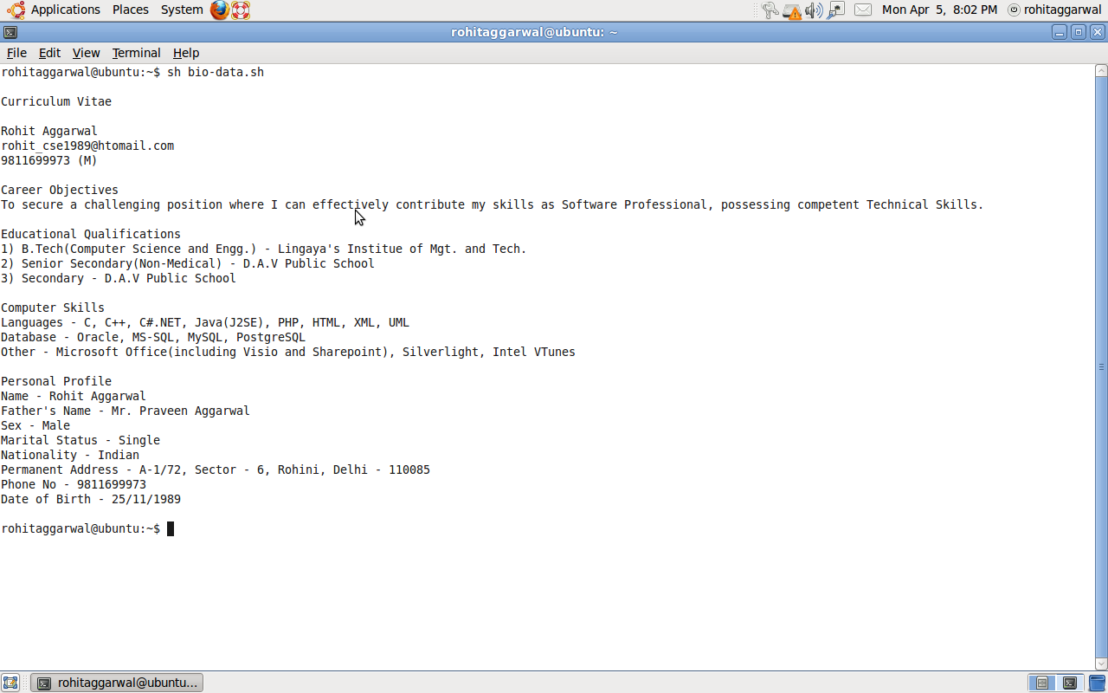**OUTPUT**